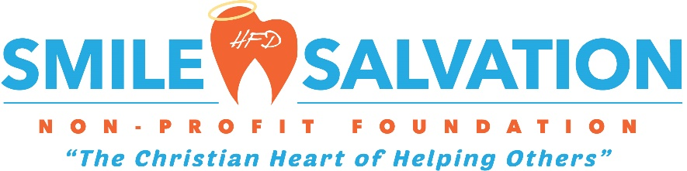

Patient’s Name: _______________________________________________________________________
Patient’s DOB: _________________ Patient’s Phone Number: _______________________________
Patient Social:________________________ Patient Email:____________________________________
Dental Insurance: Yes____ No____
If Yes, Insurance Name and ID:___________________________________________________________

Preferred Higginbotham Family Dental Location:____________________________________________

Patient’s Address: ______________________________________________________________________
_____________________________________________________________________________________

Type of Cancer: _____________________________ Chemo Start Date: _______________________
Dental Treatment Needed: _______________________________________________________________
_________ All Teeth Extracted _________Only Extract Teeth That Need Extracted
_________ Periodontal Treatment if needed

Cancer Navigator Name: _________________________________________________________________
Navigator Contact Phone Number: _________________________________
_______ Patient understands only extractions and periodontal treatment are covered under this program and any other type of treatment needed maybe at the patient’s expense.

Doctor Name: _________________________________________________________________________
Doctor Signature: ______________________________________________________________________
Please email application and any additional questions to Lai Ferrell at lferrell@higginbothamfamilydental.com

